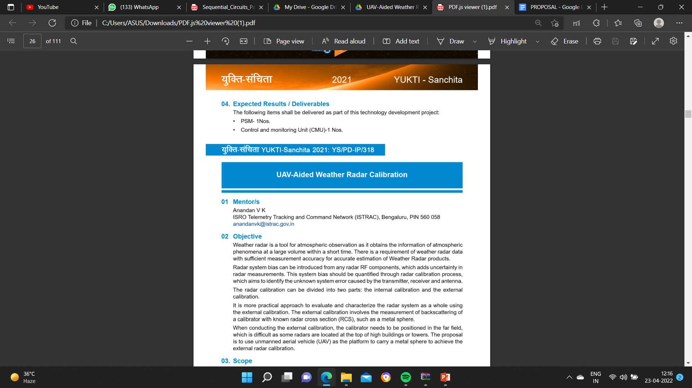

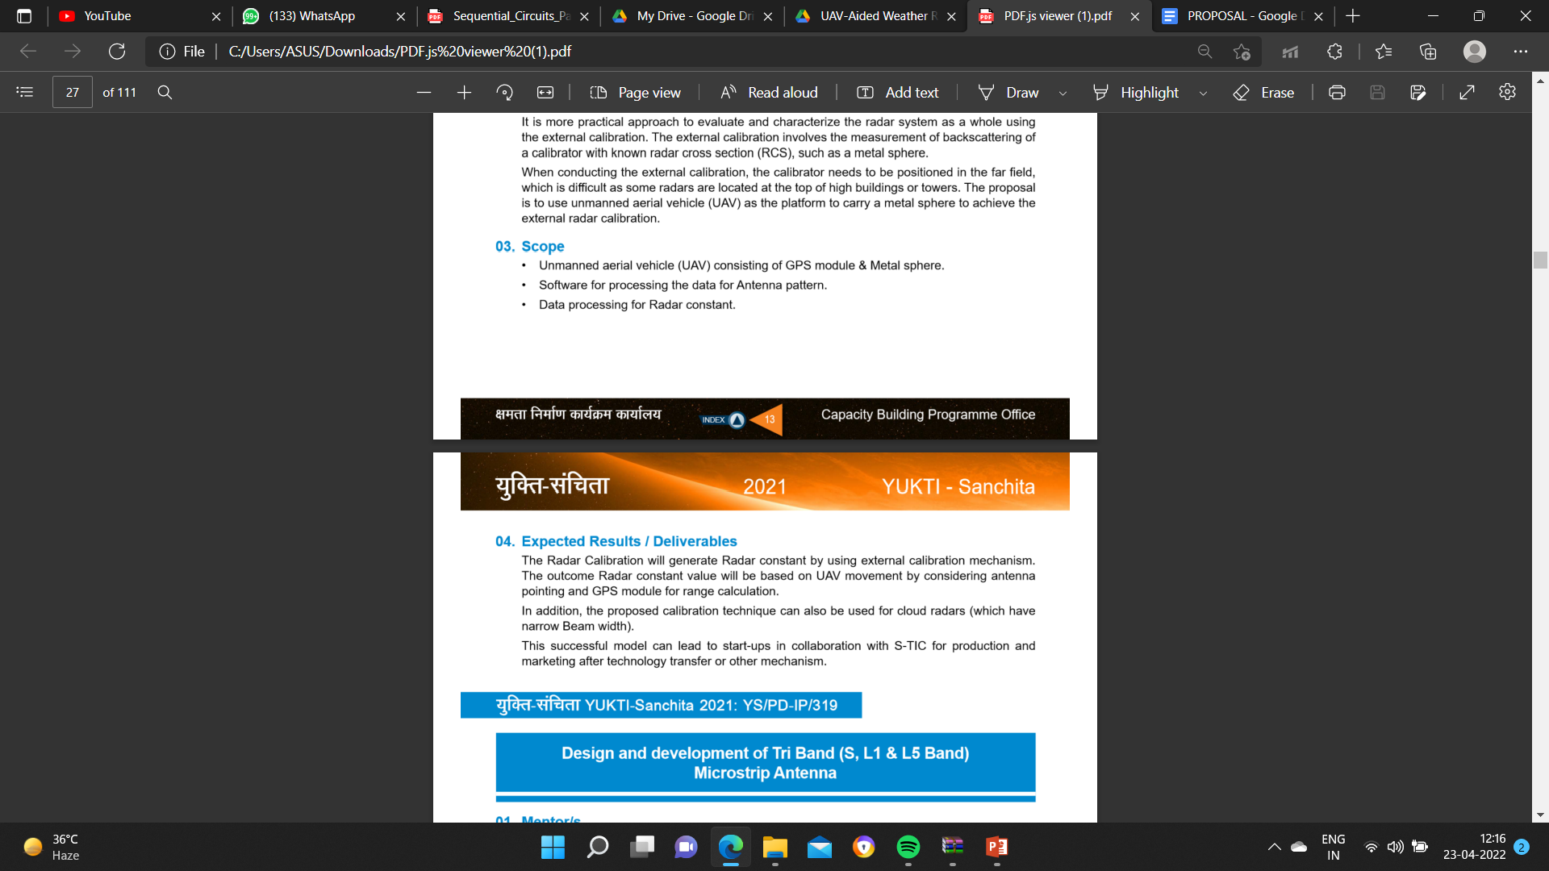

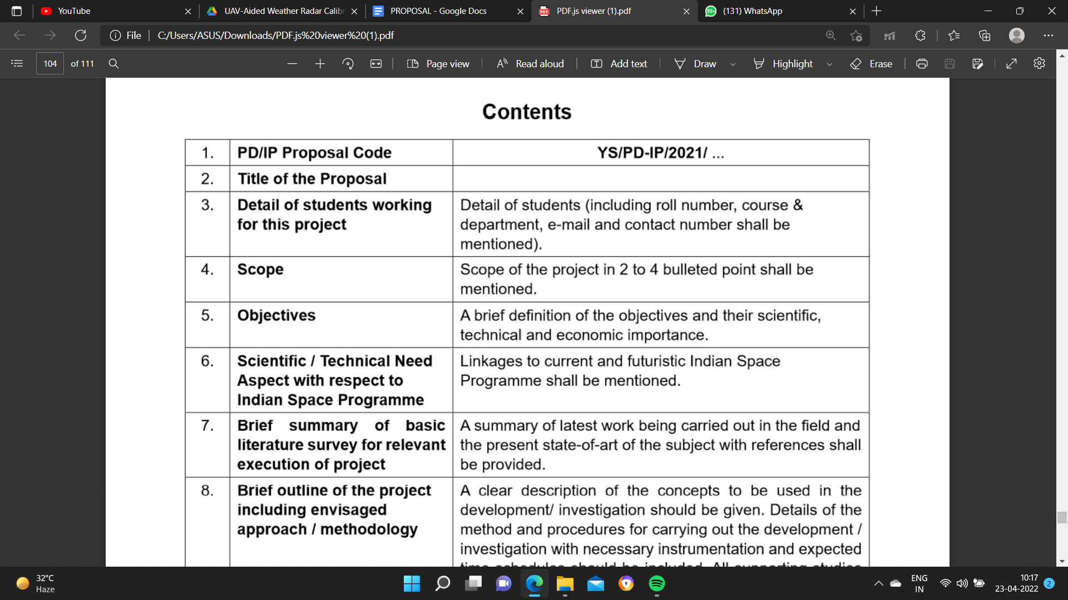

4

**SCOPE**

* Radar data processing
* Interfacing software
* UAV with GPS module

5

Atmospheric observation is made possible through weather radar, which provides data regarding the conditions of the atmosphere phenomena at a large volume within a short time. There is a requirement of weather radar data with sufficient measurement accuracy for accurate estimation of Weather Radar products. Radar system bias can be introduced from any radar F components, which adds uncertainty in radar measurements. This system bias should be quantified through a radar calibration process, which aims to identify the unknown system error caused by the transmitter, receiver and antenna. The radar calibration can be divided into two parts: the internal calibration and the external Calibration. It is a more practical approach to evaluate and characterise the radar system as a whole using the external calibration. The external calibration involves the measurement of backscattering of a calibrator with known radar cross section, such as a metal sphere.When conducting the external calibration, the calibrator needs to be positioned in the far field, which is difficult as some radars are located at the top of high buildings or towers.The proposal is to use an unmanned aerial vehicle as the platform to carry a metal sphere to achieve the external radar calibration.

3- EVERYONE

NAME - Pushpal Das

ROLL NO. - RA1911004010565

Course and Department - Btech , Electronics and Communication Engineering(ECE).

Email - [pd7000@srmist.edu.in](mailto:pd7000@srmist.edu.in)

Contact No. - 8910497557

College Name - SRM Institute of Science and Technology

Ved Prakash Dubey

RA1911033010043

BTech Computer Science and Engineering with a Specialisation in Software Engineering

[vd8413@srmist.edu.in](mailto:vd8413@srmist.edu.in)

9674990810

SRM Institute of Science and Technology

Abhishek Sarkar

Roll.no: 001910701027

Course and Department : B.E., ETCE

Email : [abhisrkr007@gmail.com](mailto:abhisrkr007@gmail.com)

Contact number: 6290782054

College Name: Jadavpur University

Suriya - Name: Suriya Devalan AR

Roll.no RA1911002010176

Course and Department : B.Tech,Mechanical

Email : [as5539@srmist.edu.in](mailto:as5539@srmist.edu.in)

Contact number: 8072137976

College Name: SRM Institute of Science and Technology

Debangan - Name: Debangan Mandal

Reg No. 19BCE0688

Course and Department: B.Tech, Computer Science and Technology

Email: [debangan.mandal@gmail.com](mailto:debangan.mandal@gmail.com)

Contact number: 6291855524

College Name: Vellore Institute of Technology, Vellore

Sayak

NAME - Sayak Sanyal

ROLL NO. - 19BEC0682

Course and Department - Btech , Electronics and Communication Engineering(ECE).

Email - [sayak.sanyal2019@vitstudent.ac.in](mailto:rohan.paul2019@vitstudent.ac.in)

Contact No. - 9123782678

College Name - VELLORE INSTITUTE OF TECHNOLOGY , VELLORE.

4- PUSHPAL

5- PUSHPAL

6- GENERAL

**Suriya**

* ISRO AND IMD carried out a calibration experiment on new X-band radar which was installed at NIOT,pallikaranai using a drone, it was the first time in the country that a drone was used to carry out calibration experiments on a weather radar.
* Hence this methodology can help the existing project by improving its efficiency like time of flight, power consumption and also their aerodynamics.

**Debangan:**

Weather radar is a well-known sensor for measuring the microphysical and dynamical aspects of precipitation with high spatial and temporal resolution. One of the most crucial criteria for reliable observations is radar calibration. Unmanned aerial vehicle (UAV)-aided radar calibration is presented in this article as a portable, cost-effective, and reproducible radar calibration approach.

**Arkadeep :**

ISRO has provided a lot of solutions in the department of UAV development and its applications. In comparison to traditional aerial surveys, which are quite expensive when a study requires a number of periodic surveys, UAVs have been successfully employed for real-time mapping, surveying, and monitoring activities with high spatial and spectral resolution data.

NORTH EASTERN SPACE APPLICATION CENTRE, has taken up the responsibility of UAV development in India. NE-SAC designed and built a Hex Copter that can carry a payload of up to 2.5 kg of various sensors such as thermal, multispectral, optical, hyperspectral, or LIDAR. Moving forward on this design and work upon it would be an aim for out team. The flight were carried out in two test sites located in the Ri Bhoi district of Meghalaya and one test site in Morigaon district of Assam of India.

**Future Aspects :**

* Drones can go where humans can't, making them perfect for perilous search and rescue missions as well as delivering essential supplies to isolated locales and disaster zones.
* The Army has placed a new order for an improved version of indigenous high-altitude tactical drones procured last year to keep a watch on the Line of Actual Control (LAC) in Ladakh, after being impressed by their performance.
* On a small scale, the drones could be implemented in areas of high security within the country for more better surveillance and might be later equipped with some aerial sedatives or some small grade weapons to seize the intruder.

**ROHAN -**

Unmanned Aerial Vehicle (UAV), popularly known as Drone, is an airborne system or an aircraft operated remotely by a human operator or autonomously by an onboard computer. UAV based Remote Sensing (UAV-RS) is the new addition to the [North Eastern Space Applications Centre (NE-SAC)](http://www.nesac.gov.in/) for large-scale mapping and real time assessment and monitoring activities of various applications.

The multi rotor based UAV has been flown in different areas of NE states by NE-SAC as part of technology developmental activities. Few tests were made based on the demands from the respective District Administrations of NE region.

This UAV based project helps to assess the damage infested on crop. An important use case is Naramari village of Morigaon District, Assam, India had been reported severe infestation of Boro Paddy by Brown Plant Hopper (BPH) insect. As per the request from officials from State Government of Assam, an UAV flight was conducted in the affected area and a total area of 0.55 sq. km was covered with a 15 minutes flight. Figure shows the categorisation of BPH infested rice fields.

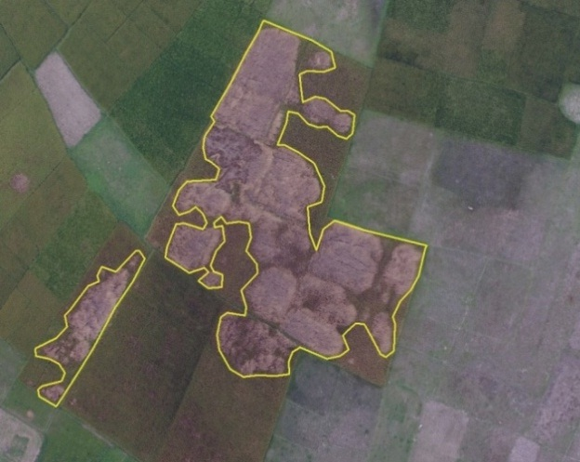

7- EVERYONE

**Abhishek**

* From the dissertation submitted by Arturo Yoshiyuki and Umeyama Matsumoto at University of Oklahoma Graduate College named “Unmanned Aerial Vehicle-Based Far-Field Antenna Characterization System For Polarimetric Weather Radars” (identifying URL: https://hdl.handle.net/11244/326678), UAV-based weather radar solutions are hypothesized to be able to replace conventional outdoor ones due to low cost and flexibility of operations. It describes necessary RF instrumentation to perform accurate measurements of a typical weather radar.
* The radiation characteristics of the probe antenna are degraded due to scattering and diffraction effects from the interaction of the antenna and the UAV. Hence, to effectively and accurately perform calibration, proper steps need to be taken to compensate the above mentioned impact on the radiation characteristics.
* The main advantage UAVs provide is that they are not restricted in movement, and with the use of a gimbal, it is possible to have an airborne measurement system with multiple degrees of freedom.
* The basic RF instrumentation that allows far-field magnitude measurements for co- and cross-polarization antenna patterns, for polarimetric weather radars, have been discussed.

**Arkadeep**

* From the paper written by Aswath and Jeevak Raj, we could find that a particular type of UAV namely **VTOLs (Vertical Take-Off and Landing)** could be efficient as it does not require any runaway to get airborne and that these types of drones are used a lot in agricultural fields, swarm-based collaborative robots, warehouse management etc.
* From the paper it was understood which type of controllers would be best fitted for such a heavy payload.and the most common among them would be **PID controller** which can be used to achieve basic hovering and attitude control
* The heaviest component is all multirotor designs is the **battery.** We can acheive a longer flight time with a more powerful battery but that might effect the overall weight distribution of the hexacopter with additional weight and in turn will affect flight time. But without the use of LIDAR, a significant amount of weight will be reduced due to not so high consumption of the battery.
* Based on the research done by Chirag Gupta, Dibyajyoti Chutia, Mhathung Kithan, Atho-O Kesiezie, Victor Saikhom, Puyam S Singh, in autonomous flying mode, the flying height and time were limited to 120 metres and 12 minutes, respectively, covering an area of two square kilometres, resulting in ground resolution of 4-5 cms, thus providing more details in a shorter flight time span while also taking safety considerations into account. Study of a settlement area, estimation of crop-infested areas in an agricultural field, and aerial survey of landslide zones are some of the remote sensing applications accomplished using our UAV. Various sections of this study explain the details of the design and integration of a lightweight multirotor UAV for remote sensing applications.

**Ved**

* Based on the results provided from *Digital Object Identifier 10.1109/ACCESS.2020.3027790* - the error metrics for the UAV calibrator - namely co-polarization mismatch and cross-pollination mismatch are comparable to that of an external calibrator on a pedestal at an elevated level. This proves that a UAV-based antenna characterization method can be as effective as an elevated range, provided that the accuracy of the navigation and tracking system are sufficient.
* Probe correction techniques can be applied, which would further improve the error levels.
* It is recommended to use a probe antenna with as narrow a beam-width as possible while still being physically realisable, and to prioritise the altitude accuracy over the x-y accuracy to keep the error levels at a minimum.
* A point to be noted in DOI:[10.1109/TGRS.2019.2933912](https://doi.org/10.1109/TGRS.2019.2933912) is that measurements at higher altitudes were not performed due to lawful restrictions on drone flight, specifically values of range resolution should be 30m not 3m. Hence, we can try making more observations in operational mode and take the necessary observations.

**Suriya**

* Based on the paper written by Jiapeng Yin , Student Member, IEEE, Peter Hoogeboom, Christine Unal, Herman Russchenberg , Fred van der Zwan, and Erik Oudejans, We can get a conclusion that using a UAV to carry a metal sphere with an external GPS box underneath the sphere, the proper flying modes, namely horizontal and vertical zigzag movements, are designed to intercept the antenna gain pattern at several points.
* With the GPS coordinates obtained from the UAV and the external GPS box, it is possible to obtain the positions of the sphere and output its azimuth and elevation angles. Then, the antenna pointing calibration can be conducted. The S Band TARA is placed 350m at 12 degree angle to receive the signals from the GPS.
* Hence we need to provide a proper chassis that is metal sphere like or an airfoil shape to improve the aerodynamic performance. We place a powerbank, MCU,Reciver and antenna in the 3d printed object. Small gap must be made in the 3d printed object so that the antenna can transmit the signals with the S band. Although the hole can change the direction of the air trivially we need to try to maintain the centre of mass of the object which is a bit complicated but can be achieved to an extent. Reference IEEE TRANSACTIONS ON GEOSCIENCE AND REMOTE SENSING, VOL. 57, NO. 12, DECEMBER 2019

**Debangan**

For quantitative applications such as rainfall estimate, severe weather monitoring and nowcasting, and assimilation in numerical weather prediction models, the stability and precision of weather radar reflectivity calibration are critical. Various radar calibration and monitoring techniques have been established, however integrated approaches, i.e. combining diverse calibration techniques, have just lately been offered. Three methodologies are utilised in this paper: (1) ground clutter monitoring, (2) comparisons with space-borne radars, and (3) polarimetric variable self-consistency.

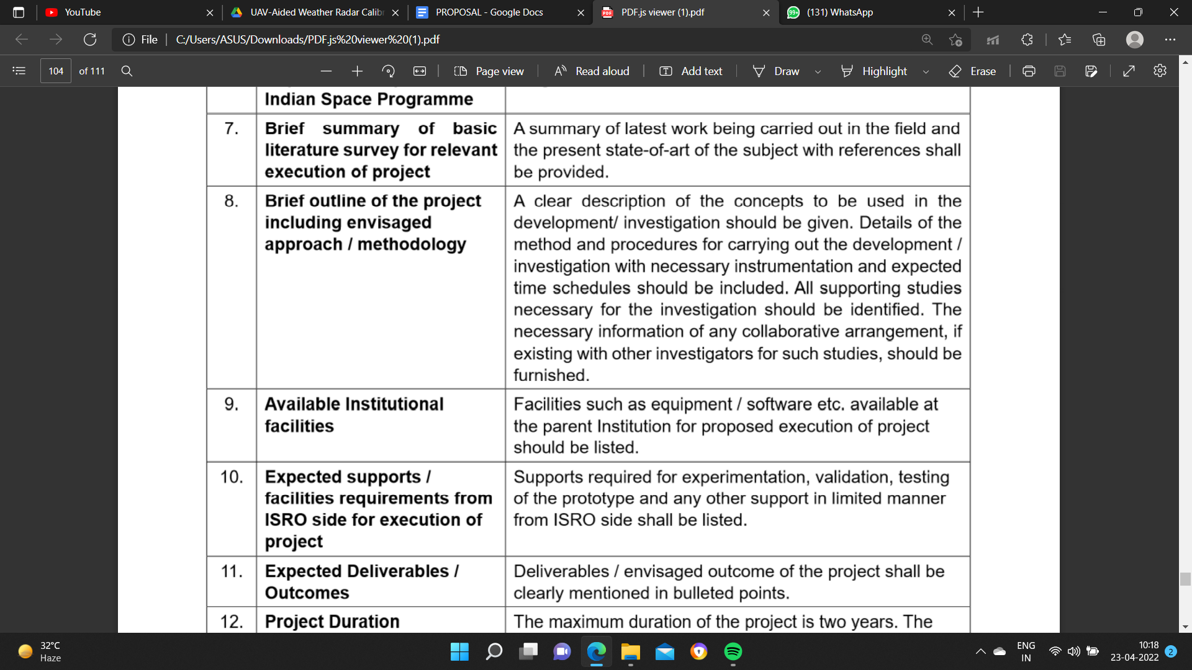

8- METHODOLOGY

Hardware -

**Rohan -**

* As the first step we need to collect all the components and sensors based on our requirements and choose the best sensors possible providing the most accurate results.
* Assemble the BDLC in the frame and connect the electronic speed controllers to it .
* Attach all these to the Pixhawk flight controller accordingly.
* Attach the gps module also to the flight controller.
* After assembling the drone we need to place the raspberry pi in such a manner that the drone can be balanced.
* Attach a camera module also to the raspberry pi and program the pi.

Mechanical:-

**Arkadeep**

* Six motors are mounted to the frame with arms and rotate the propeller at extremely high rates to provide propulsion in a hexacopter.
* Two landing gears are used to provide stability while landing and must be flexible to face any sudden jerk and prevent the toppling of the UAV
* Three motors rotate in clockwise (CW) and counterclockwise (CCW) orientations to achieve stability. It is possible to cancel the net moment about the drone's yaw axis with this setup.
* BLDC motors are utilised in multi-rotors, and the rotational speed is controlled utilising three different phases of current. With the help of an ESC, the motors' programmed rotation speed is maintained (Electronic Speed Controllers). ESCs constantly monitor the motor's feedback current and make minute adjustments to the motor's input current.
* Batteries are used to power the on-board computer, sensors and motors.
* Based on these mentioned components, a physical model of the hexacopter will be designed in Solidworks and the final 3D CAD(Computer Aided Design) model is exported
* The whole weight distribution of the hexacopter must be evaluated; this enables for component analysis and highlights the relevance of each portion, as well as tracking its performance with past and future iterations of the Multi-rotor designs.

9- SIR

10- SIR

11- EVERYONE

* **ELECTRONIC**
  + **Abhishek:** 1) A cost-effective, mobile, in-situ UAV-based far-field antenna characterization system for polarimetric weather radar applications. 2) A means for accurate in-situ polarimetric calibration.
* **SOFTWARE**
  + **Ved:** 1) Obtain position of the calibration sphere using the GPS unit and output its azimuth and elevation angles. With this the antenna pointing calibrations can be conducted. 2) Finally, with the measurements complete, the interpolated 2-D antenna pattern can be received and depicted using appropriate software.
  + **Debangan**
  + To finish the calibration procedure, a UAV acts as a steady aerial platform holding a metal sphere that flies over the radar illumination zones. The UAV’s flight routine may be pre programmed, allowing the antenna pattern to be retrieved for various elevation and azimuth angles. A real-time single-frequency exact point positioning-type global navigation satellite system solution is being developed to determine the sphere's position. Furthermore, the radar constant is computed in the range-Doppler domain, and only the data where the metal sphere distinguishes itself from clutter and other objects is chosen. The calibration effort employs the S-band polarimetric Doppler transportable atmospheric radar (TARA). The following are the outcomes of the experiments:
  + 1. antenna pointing calibration can be completed
  + 2. antenna pattern can be retrieved and weather radar constant can be accurately calculated.
* **MECHANICAL**

**Suriya-**

1. Able to figure out one of the best aerodynamic shapes from a metal sphere leading to better ergonomics.
2. Work on evenly balancing the centre of gravity in UAV.

**Arkadeep:**

1. Design and integration of a small multirotor UAV with a payload capacity of the required weight, a flight endurance of 30-40 minutes, and a designated range.
2. Working on the frame design, to make the UAV more aerodynamic in nature thus providing ingenious solutions to tackle wind problems.

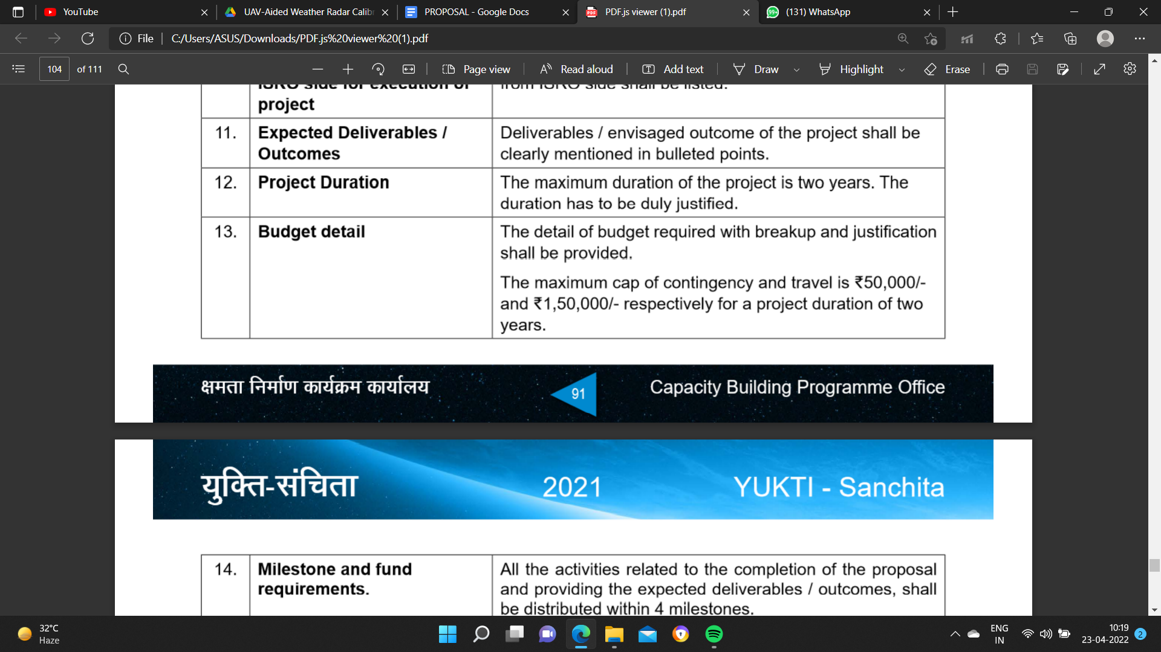

12- SIR

13- EVERYONE

* **ELECTRONIC**

**Rohan -**

| **Serial No.** | **Component** | **Quantity** | **Cost (Rs)** |
| --- | --- | --- | --- |
| **1** | Bosch Sensortec BME280 | 1 | **1000** |
| **2** | Silicon Laboratories SI1145 | 1 | **2000** |
| **3** | Raspberry pi | 1 | **12000** |
| **4** | Readytosky 80A | 6 | **12000** |
| **5** | Pixhawk 32 Bit Flight Controller | 1 | **13000** |
| **6** | U-BLOX NEO-M8N | 1 | **2000** |
| **7** | [FLY SKY FS IA6B](https://www.electronicscomp.com/drone-transmitter-receiver/fly-sky-fs-ia6b-rf-2.4ghz-6ch-ppm-output-with-ibus-port-receiver) | 1 | **1250** |
| **8** | Standard Propeller | 10 | **1000** |
| **9** | Frame | 1 | **4000** |
| **10** | Landing Gears | 1 | **1000** |
| **11** | Lipo Batteries | 1 | **2000** |
| **12** | Brushless DC motor | 6 | **9000** |
| **13** | Shock Absorber for APM/KK/MWC/PixHawk | 1 | **1300** |
| **14** | Anti-vibration Washer Rubber Damping Ball | 10 | **1400** |

**Total Hardware cost - Rs 62,950/-**

* **SOFTWARE**

On behalf of the software team it will take us 10 to 12 weeks to complete the backend.

* **MECHANICAL**

On behalf of the Mechanical team, it will take 9 to 10 weeks to develop our project.

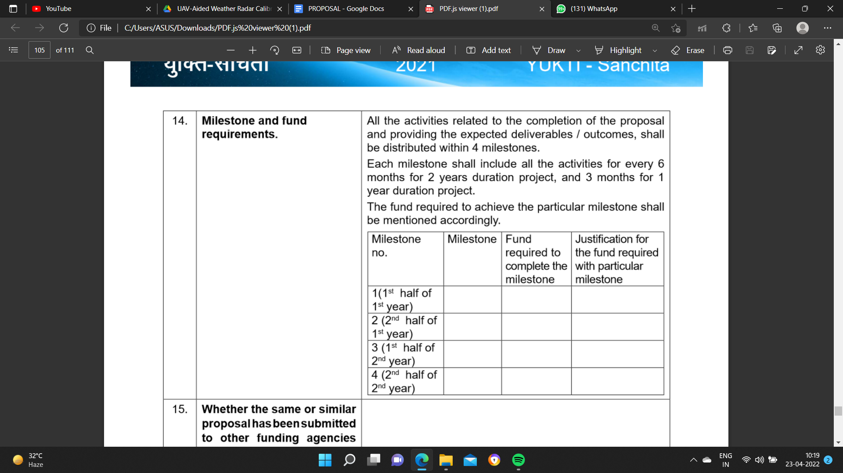

14- SIR

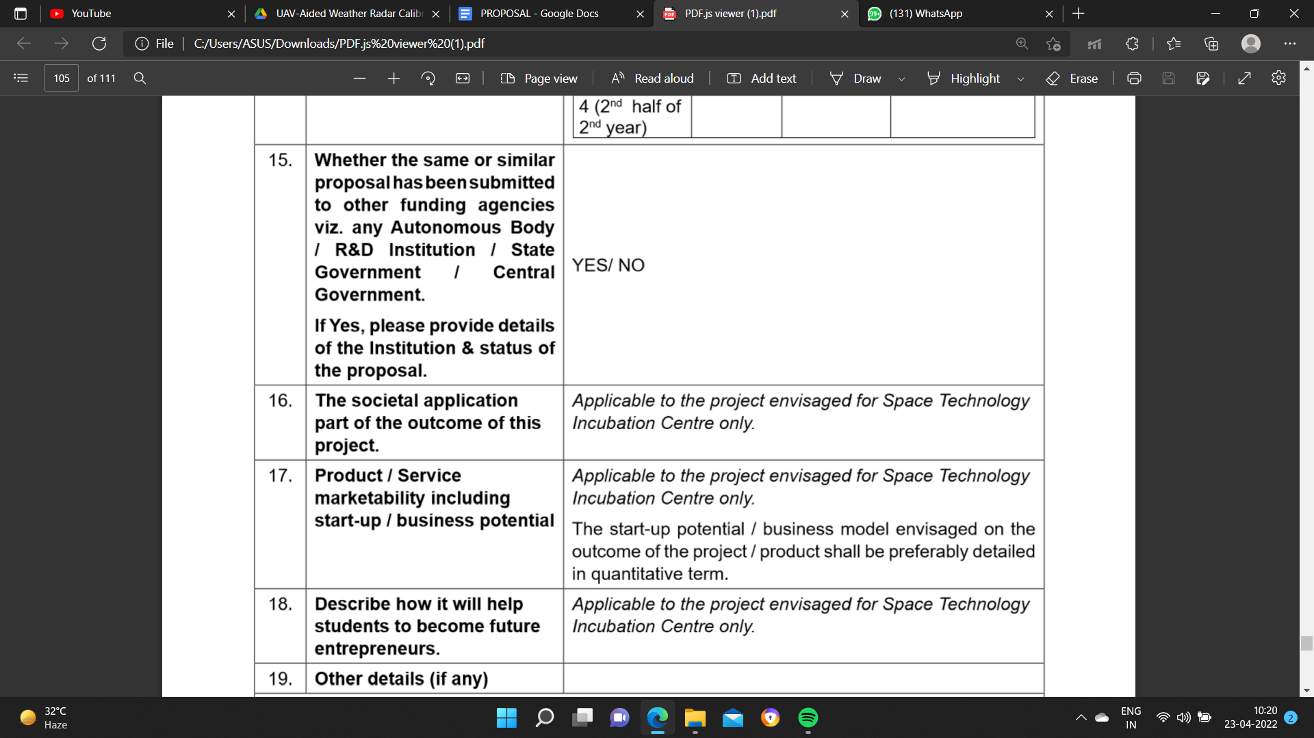

15- SIR

16- PUSHPAL

The societal application of this project is as simple as that that in many of the scenarios we often face a glitch or an error in the live forecasting of the weather based on the atmospheric layer as a result of it to study and grow more in deep with the results and outcome and give as much as efficiency and accuracy as it can be will be the best output for everyone has a hole when it’s live weather forecasting and the need of people to know about weather detail.

17- PUSHPAL

Start up or business potential as we can see is to unlimited offset into a particular set of market the particular set of market can only be targeted into sectors owning satellites and when the word satellite comes today forecasting is what we human beings are updated to so the market capability for its growth its extended to news channels and not only that even for perfect accuracy as a measurement instruments to various sorts of lab for carrying out many such research works so if we view this as a start-up or a business model the growth is where enormous as the inside layer of it rather than not outside or we can say that people will not be exposed to it directly but indirectly that is what it potentially have a gravity towards it.

18- PUSHPAL

Today India our country as we know is on the verge of start-ups and many such business plans but if we see things very technically then we the engineering student can make it happen with the support of organisations all we need is a bit of patience hard work and vision that we all carry in the commencement of the project in today’s generation there is not a single leader in the team what we believe is we are our own leaders we are our own master we are our own captain of the ship so it’s us who decide in what direction we want the product to grow when it’s too accurate to perfect and up to the market so it is asked the entrepreneurs who knows the limit of the product all we need is a chance and sacrifices to to prove what our words mean.